Submitting or Confirming Your COVID-19 Vaccination on the Yale Vaccine Portal (rev 10/25/22)
Yale requires all faculty and staff to submit their vaccination dates and record on the Yale Employee Vaccine Portal or request an exemption. New hires are required to upload their information or apply for an exemption before or on their first day of employment.
Even if you can see your vaccination information in MyChart or another electronic medical record, it does not mean that your information is in the Employee Vaccine Portal. It is important to log and confirm that your information is verified.
Completing this process will require:
- Your NetID and password. If you need assistance, please contact the Help Desk at 203-432-9000.
- Being enrolled in DUO Everywhere.
- An image of your completed COVID-19 Vaccine Record or your immunization record that clearly shows your name, date of birth, the vaccine manufacturer, date(s) of your vaccination and the clinic site. Incomplete documentation will not be verified.
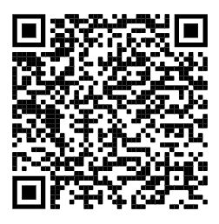
Follow These Steps to Submit or Confirm Your Vaccination
Access the Yale Employee Vaccine Portal or hold your camera over this QR code

(Students should use the Student Vaccine Portal).
If you are using a smartphone, click on the 3 bars on the left and then “Immunization”

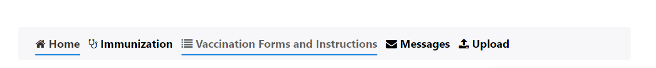
If you are using a computer, click the “Immunization” tab on the navigation bar at the top of the page.

Click the red “HERE” hyperlink which will take you to a screen that shows your vaccinations on file and your complaince status with Yale’s Vaccination Policy.
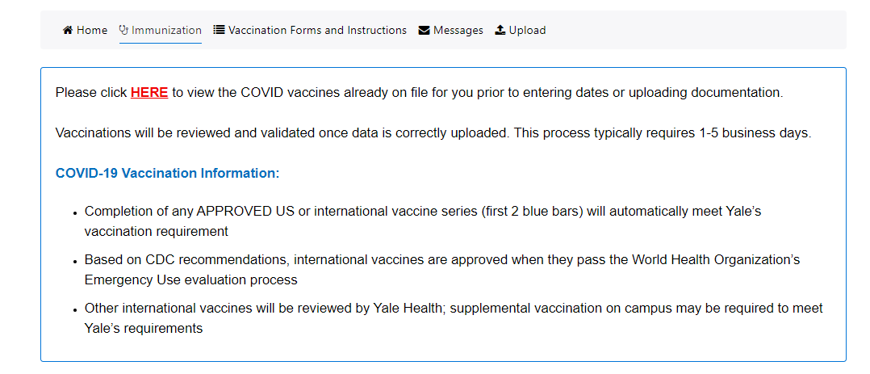

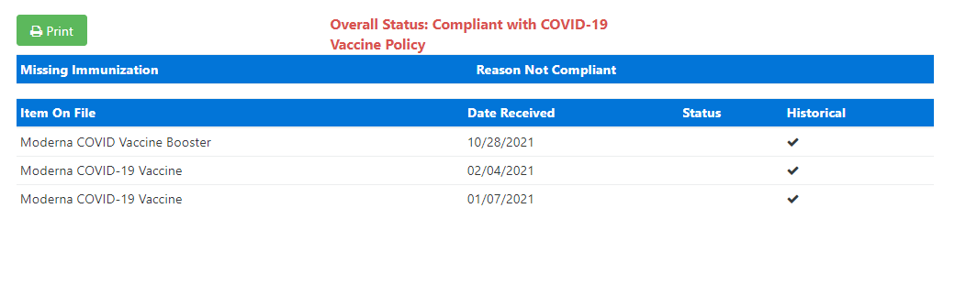

- “Overall Status: Compliant with COVID-19 Vaccine Policy,” means your information is complete, and no further action is necessary.
- “Overall Status: Not Compliant with COVID-19 Vaccine Policy,” means you need to enter your vaccination date(s) and upload your documentation.
Another way to see if your information is complete is to click on the “Immunization” link and look for “Verified” above the blue bar(s).
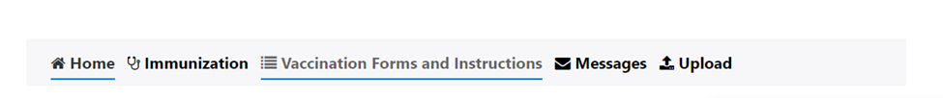

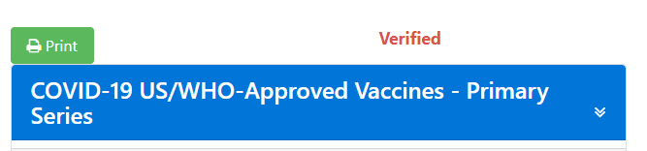

(Note, students will see Verified – OFF Health Hold, Not Verified – ON Health Hold, Missing Info – ON Health Hold, or No Data)

How to Upload Your COVID-19 Primary Series and/or Most Recent Booster Dose

- Click the appropriate blue bar for either a primary series or booster. Note, there are 2 booster sections – one for the “Updated BIVALENT Booster” and another for the most recent dose of the “Original Monovalent Booster.”
  - Enter the date(s) you received your primary series and/or your most recent booster dose. Make sure to enter the date(s) under the correct manufacturer (e.g., Pfizer, Moderna).
  - Click the blue “Submit” button (found at both the bottom or side of the page).
  - Proceed with uploading a copy of your COVID-19 Vaccination Record Card or other immunization record.

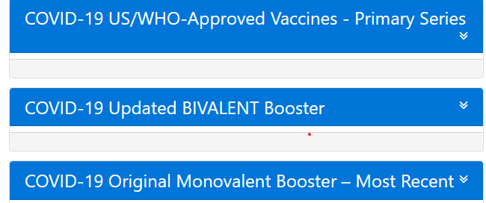

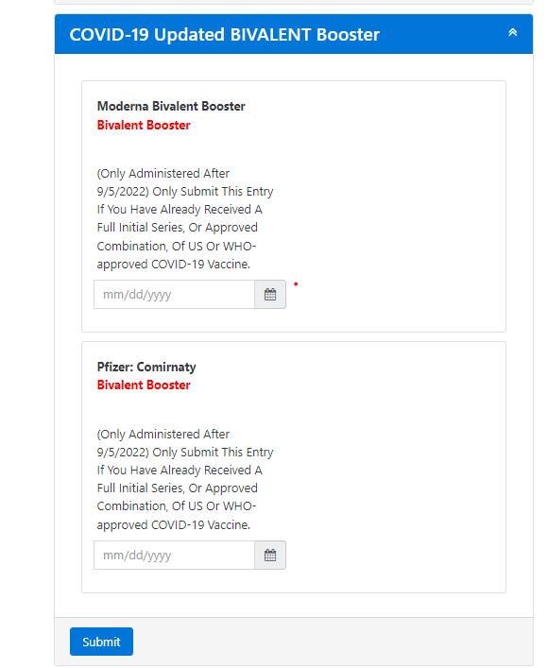

- You will not be considered compliant until your vaccination dates and supporting documentation are verified, which can take 1-5 business days. Go back into the portal to check. If your information is not verified within this timeframe, check to see if you have received a message regarding the issue.
- NOTE: This message will only appear on the portal and does not go to your Yale or personal email.
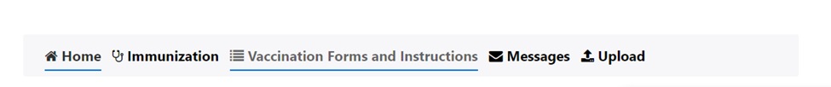

How to Upload Your COVID-19 Vaccination Documentation

If you are using your smartphone, click on the 3 bars on the left and then “Upload”
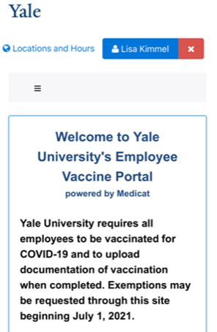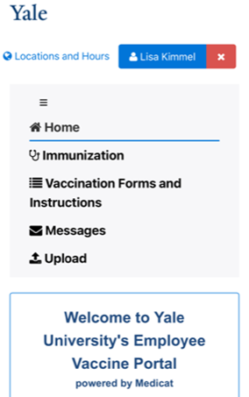

- Under “Choose the document you are uploading,” select “COVID Vaccine Records.”
- Click “Select File.”
- You can take a photo of your card or browse to upload an image that you have saved.
- Click “Upload.”
If you are uploading from a computer
- Scan or take a photo of your documentation (COVID-19 Vaccination Record Card or your immunization record from your MyChart account with your name and date of birth) and save to a file on your computer or mobile device.
- If you are not still on the Yale Employee Vaccine Portal, log back on.
- Click the “Upload” button on the navigation bar.
- Choose the document you are uploading from the dropdown menu (for example, COVID Vaccine Records).
- Choose “Select File.”
- Browse to find the file that you saved on your computer or mobile device.
- Click “Open.”
- Click “Upload.”
- When uploaded correctly, the document will appear in the “Documents already on file” section of the page.
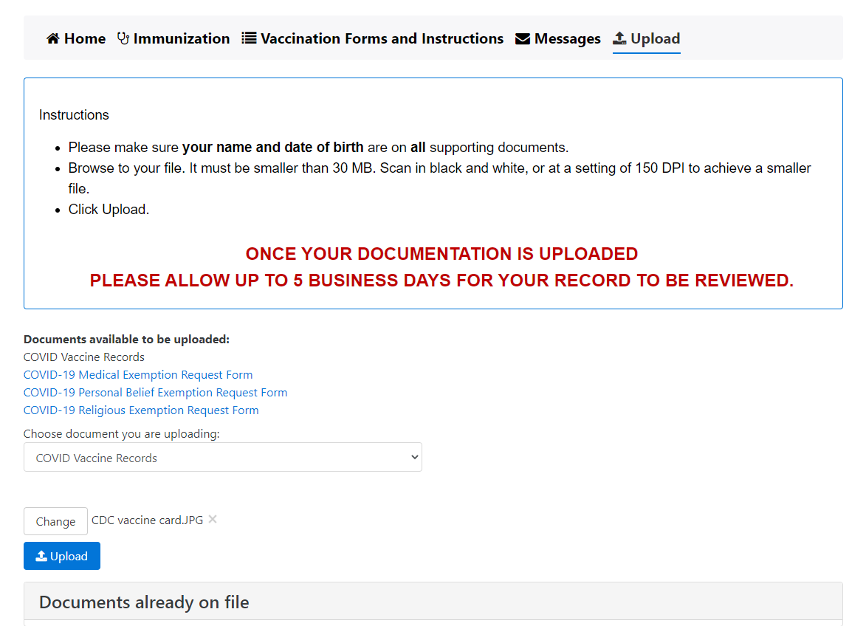

If You Have Lost Your COVID-19 Vaccination Record Card
If you have lost your COVID-19 Vaccination Record Card, you may be able to get your immunization information from your MyChart account.
- Go to MyChart on the web or the MyChart app and log in.
- Click on the “Your Menu” icon.
- Under the “Health and Wellness” section, click “COVID-19 (Vacc Status and Test Results).”
- Download a PDF of your vaccination information.

If you received your vaccinations in Connecticut, you can also access your immunization record through CT WiZ Access My Immunization Record

COVID-19 Vaccine Exemption Requests
Those requesting an exemption must access, complete, and upload the request forms through the following links:
Faculty/Staff COVID-19 Vaccine Exemption Form
Student COVID-19 Vaccine Exemption Form

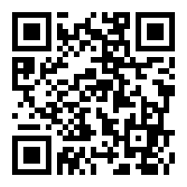
How to Schedule a Vaccination Appointment
- You may schedule your vaccination online through the Yale COVID-19 Vaccine Program. Your information will automatically be uploaded into the Employee Vaccine Portal.

- Vaccines are also available at clinics and pharmacies around the state. You will need to upload your information after receiving your vaccination.
- If you need assistance, you may call the Campus COVID Resource Line at 203-432-6604.

