A Decision Aid for Colon Cancer Screening

This information is for you if you:
- are between the ages of 45 and 75.
- have not had colon cancer.

Facts about Colon Cancer
- Colon cancer starts off as a polyp in the large intestine also called the colon.
- Polyps are abnormal growths in the colon.
- Polyps and early stage colon cancer do not always cause people to have problems or symptoms.
- Colon cancer usually grows slowly.

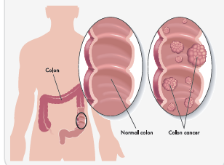

What are my screening options?
Doctors generally recommend a colonoscopy, and a colonoscopy is a very good test. But, some people do not want a colonoscopy. For people who do not want a colonoscopy, there is another test that can be done at home. It is called the Stool Blood Test (also known as a FIT Test). A colonoscopy may be a little better than a stool blood test, but it has some risks. The best test is the one that gets done.

Why should I get screened?
Screening for colon cancer saves lives. It is important to have a screening test before symptoms begin. With screening, cancer can be caught in the early stages and before it spreads to other parts of the body. In some cases, screening prevents colon cancer. Fortunately, there are other screening options for people who do not want a colonoscopy.

Which Test is Right for Me?

 | Colonoscopy | Stool Blood (FIT) Test
Test description | 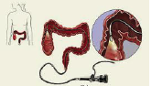  The doctor uses a narrow tube to look inside your colon. The doctor will remove any polyps to prevent cancer from developing. | 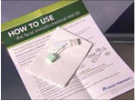  You will collect a small stool sample to be tested for blood.
How do I prepare for the screening test? | You drink medication that cleans out your colon the night before the test. This causes loose stools, gas, bloating, and a need to go to the bathroom more often. | There is no preparation needed.
Where do I take the screening test? | At an endoscopy center. | At home.
How long does the screening test take? | Less than 1 hour. After the test, you will need the rest of the day to recover. Some people need several days to recover completely. | Less than 5 minutes.
Does it require help from family or friends on test day? | Yes, you will be given medication to help you relax. This means you will need someone to drive you home after the test. | No.
What does the screening test find? | Polyps and colon cancer. | Blood in your stool, which can be from polyps or colon cancer.
What may the screening test find other than cancer? | Polyps that are not cancer. | Blood when nothing is wrong.
How often do I need the screening test? | Every 10 years, if no polyps are found. Every 3-5 years if polyps are found. | Every year, if no blood is found.
Will I need follow-up after the test? | No. | Yes, if the test finds blood, you will need a colonoscopy. Every year, about 8 out of 100 people tested will need a follow-up colonoscopy.
Does the screening test reduce the risk of death from colon cancer? | Yes, if you complete regular screenings. | Yes, if you complete yearly testing.
Is there a chance of injury from the screening test? | Out of 1,000 colonoscopies done: 3 people will have complications requiring hospitalization. Very rarely, someone may die from complications. | There is no risk of injury from the stool blood test.

Which test is right for me?
You may decide to have a colonoscopy because: | You may decide to have a stool blood (FIT) test because:
- It finds polyps and removes polyps during screening  - It does not have to be done yearly  - It does not involve you handling your stool | - There is no risk of injury  - It is done at home  - You don't mind doing a yearly test  - You are willing to have a colonoscopy if the test is positive.

How many lives does screening save?

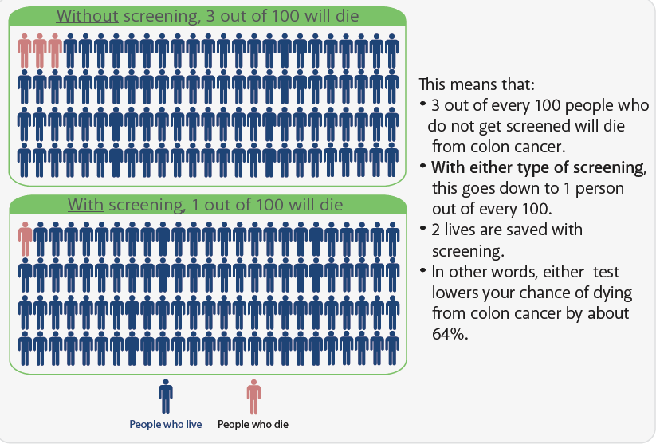

What are the Next Steps?
If you know which choice is best for you:

If you know you will get a colonoscopy | Speak with your provider for a referral. You can call Internal Medicine at 203-432-0038 or send your Internal Medicine provider a MyChart message.
I you know you will get a stool blood (FIT) test | You can the request the test by calling Internal Medicine at 203-432-0038 or sending your Internal Medicine provider a MyChart message. The test will be ordered for you and can be picked up at any Quest Lab or mailed to you with a prepaid return envelope.

Still not sure?
Screening is important for everyone, but not everyone has the same questions or concerns. Use the space below to write down questions or concerns you may have and want to discuss. If you would like to discuss your screening options with your provider, call Internal Medicine at 203-432-0038 to schedule an appointment.

______________________________________________________________________

______________________________________________________________________

______________________________________________________________________

This information is adapted and used with permission from the University of Colorado School of Medicine.

Revised 10.18.22

